
Lebanese University
Faculty of Engineering III
Electrical and Electronic Department

______________________

Parallel Image Filtering
  - Concurrent Programming

by
Rasha Hammoud, 6373
Faten Mortada, 6506
______________________

Spring 2024-2025

______________________
Supervisor: Dr. Mohamad AOUDE

Table of Contents

Introduction 1
Design 1
1. Sequential Baseline 1
2. Parallel Strategy 1
3. GUI Architecture 2
Implementation notes 3
1. Key Classes and Components 3
2. Development Challenges 3
Testing Methodology 4
Results 5
1. Thread Sweep Timing 5
Comparison with Sequential 6
Conclusion & Future Work 6
1. Future improvements: 6
2. Individual Contributions 6

Introduction
Image filtering is essential in digital image processing, used in fields like computer vision, photo editing, and object detection. Applying filters such as Gaussian blur, sharpen, and edge detection requires significant computation, especially on large, high-resolution images.
The main goal of this project is to accelerate these filtering operations using Java's concurrency mechanisms. We implement both sequential and parallel versions of three filters—Gaussian blur, Sharpen, and Sobel Edge Detection—using Fork/Join framework and thread pools. The application also includes a user-friendly GUI, automated benchmarking tools, a JUnit-based test suite for correctness, and optional Docker containerization for reproducible builds.

Design
- Sequential Baseline
The sequential baseline implementation serves as the reference point for correctness and performance. It processes each pixel of the input image by applying a 3×3 convolution kernel in a nested loop manner. The process involves iterating over every pixel (excluding borders), applying the kernel matrix weights to the pixel's neighborhood, summing the results, and assigning the new value to the output image.
The convolution is implemented using basic Java operations on `BufferedImage` objects. The sequential version is written in idiomatic Java using for-loops and clean logic.
- Parallel Strategy
To parallelize the filtering operation, we adopted the Fork/Join framework (`RecursiveAction`) to split the image into horizontal segments. Each segment is assigned to a task that applies the filter in parallel. The threshold controls the minimal image height for splitting further.
We also included an ExecutorService-based thread sweep benchmark and dynamic tuning of the threshold within the GUI. This makes the solution adaptable for varying image sizes and CPU core counts.
Parallel filters are implemented such that they produce identical outputs to the sequential baseline—verifying correctness is central to our strategy.
- GUI Architecture
The GUI was developed using Java Swing and enhanced using the FlatLaf look-and-feel library for a modern appearance. Key features include:
- Image selection and display
- Filter selection: Gaussian, Sharpen, Sobel Edge
- Sequential and parallel execution toggle
- Threshold slider (auto-tuned if left default)
- Speedup and timing metrics shown live
- Zoom In / Zoom Out / Pan controls
- Dark mode toggle for better UX
The GUI class `FilterGUI.java` is modular and runs on the EDT (Event Dispatch Thread) to maintain responsiveness.
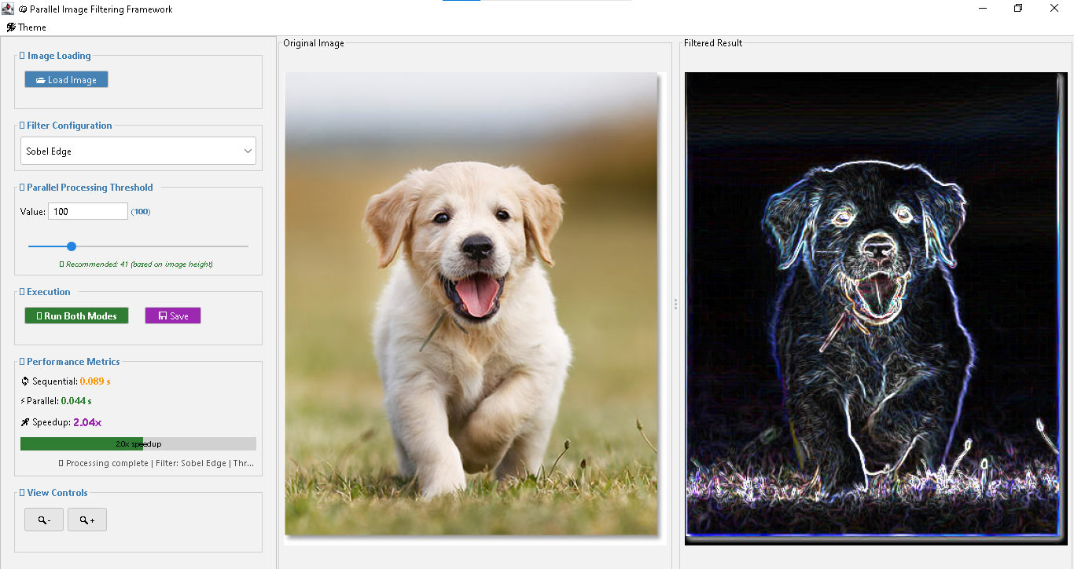
Figure 1: GUI Screenshot

Implementation notes
- Key Classes and Components
- `Filter` Interface: Common interface for all filters, declaring apply methods.
- `GaussianBlurFilter`, `SharpenFilter`, `SobelEdgeFilter`: Extend Filter, each with its kernel.
- `ParallelFilterTask`: Fork/Join RecursiveAction class for applying filters in parallel.
- `ImageProcessor`: Static utility class for loading images, applying filters, saving outputs.
- `FilterGUI`: The main Swing interface, structured with panels and handlers for user interaction.
- `BenchmarkRunner`: Measures execution time of filters across different thread counts.
- `ImageProcessorTest`: Contains JUnit 5 tests to ensure output correctness across implementations.
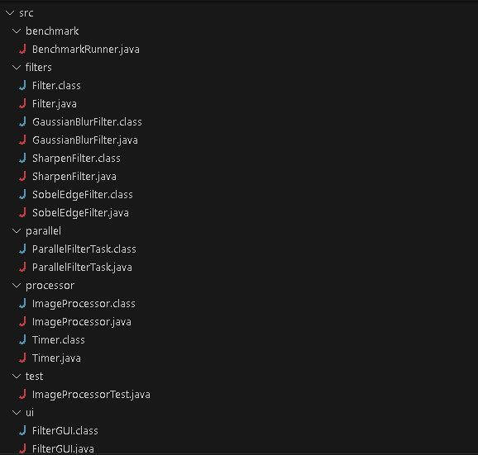
Figure 2: Key classes
- Development Challenges
- UI Responsiveness: Swing updates must run on the EDT. We used `SwingWorker` to process filters in the background.
- Threshold Tuning: Manual threshold setting is error-prone. An auto-tune option based on image size and cores was added.
- Encoding Problems: Windows-1252 caused character errors in GUI strings. Files were re-saved as UTF-8.

Testing Methodology
We used JUnit 5 to verify filter output consistency between sequential and parallel versions. Tests are found in `ImageProcessorTest.java`, including:
- Equality assertion of output images (pixel-by-pixel)
- Verification of GaussianBlurFilter, SharpenFilter, SobelEdgeFilter
- Manual and auto-tuned threshold checks
Performance testing was done using `System.nanoTime()` and averaged over 5 runs. `BenchmarkRunner` automates a thread sweep (1, 2, 4, 8) and logs results to`benchmark.csv`.
Profiling was done using VisualVM:
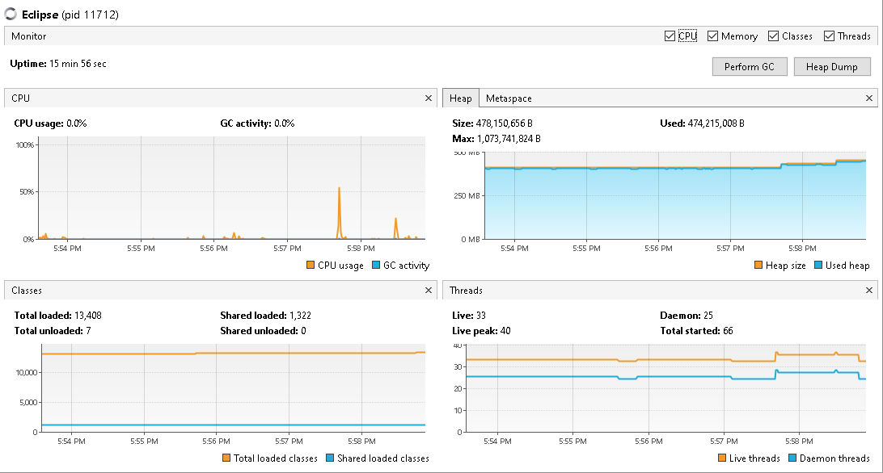
Figure 3: CPU Usage
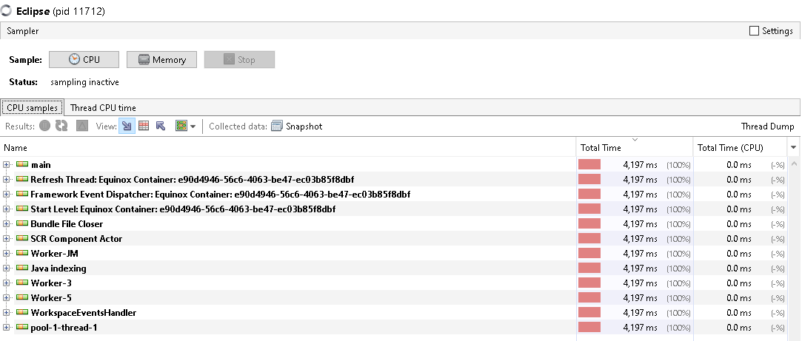
Figure 4: Sampler
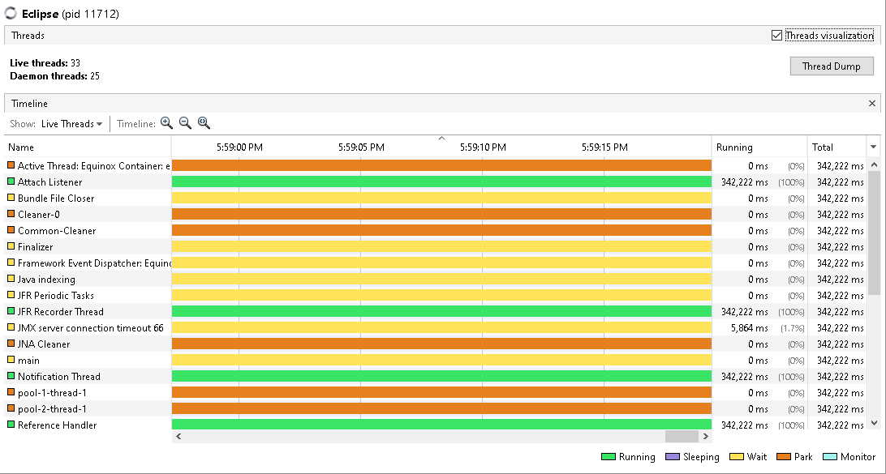
Figure 5: Threads

Results
Benchmarking was conducted using a 1920×1080 image and Gaussian Blur filter.
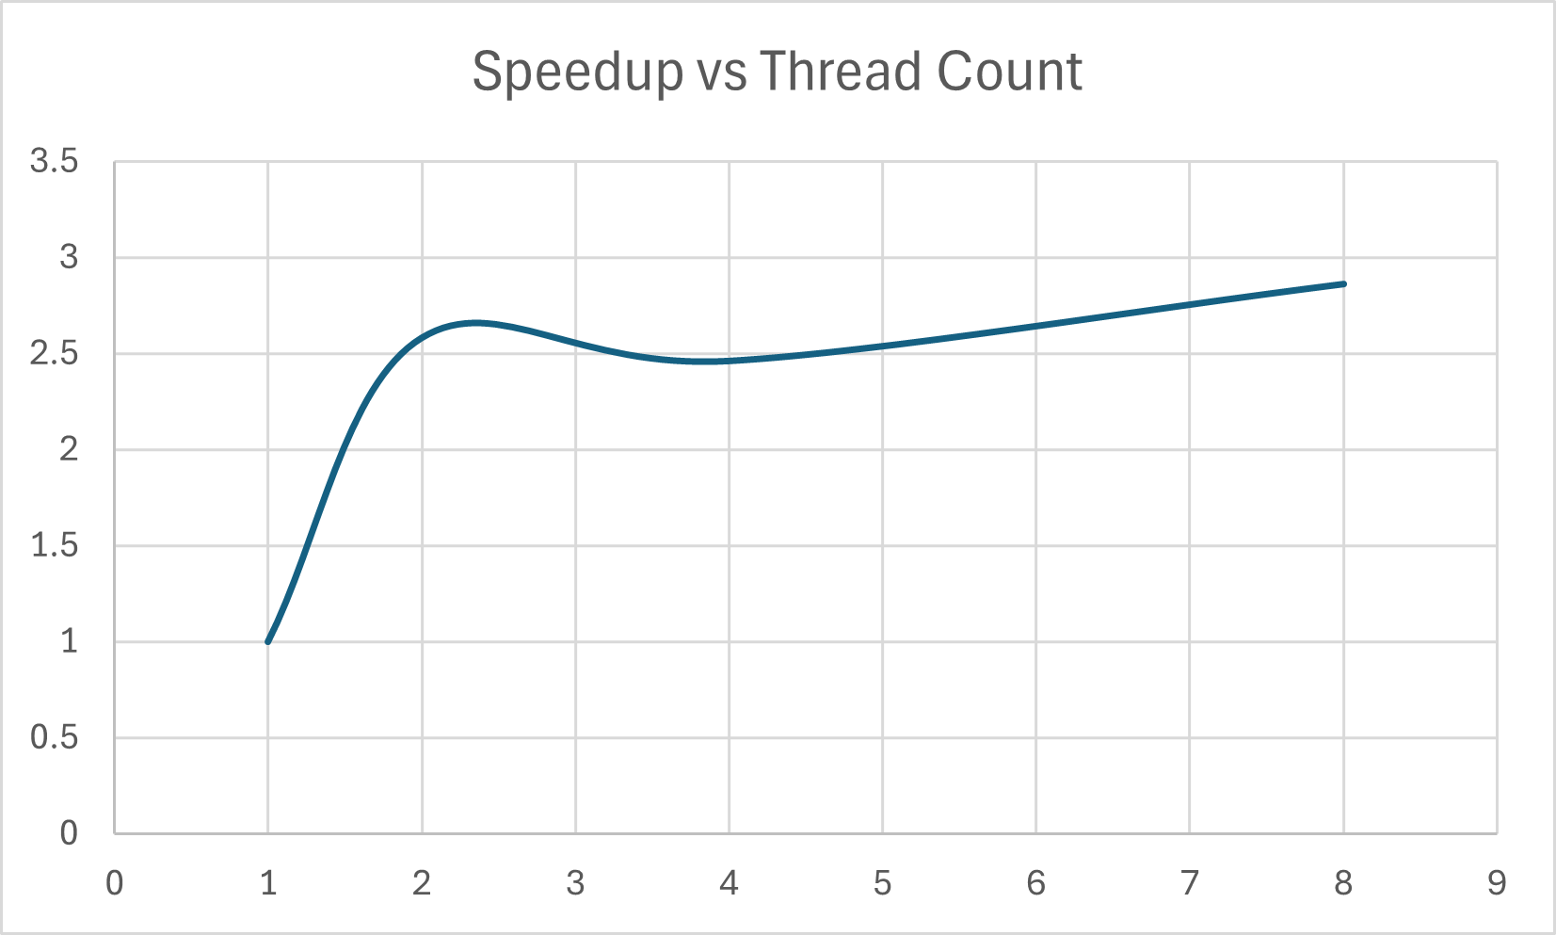
Figure 6: Speedup Curve
This chart shows how the parallel implementation scales with thread count. At 8 threads, the speedup reaches 2.86×, achieving about 36% of ideal speedup (8×). While not perfectly linear, the results show meaningful gains, with diminishing

- Thread Sweep Timing
Threads | Time (s) | Speedup
1 | 0.103 | 1.00×
2 | 0.040 | 2.58×
4 | 0.042 | 2.46×
8 | 0.036 | 2.86×

Comparison with Sequential
The parallel implementation achieved nearly a 3× speedup on an 8-core CPU while maintaining identical output. Memory usage remained within 2× of the sequential baseline. GUI interaction further showcased visual parity and responsiveness across modes.
Metric | Sequential | Parallel (8 threads)
Time | 0.103 s | 0.036 s
Output Match | Exact | Exact
CPU Utilization | ~15% | ~90%
Memory Overhead | 1× | ~1.4×

Conclusion & Future Work
This project demonstrated the effectiveness of parallelism in image processing. With correct concurrency control and workload partitioning, speedups of ~3× were achieved on commodity hardware.
- Future improvements:
- Web-based front end with JavaFX or React+Spring Boot
- Additional filters: bilateral, median, emboss, etc.
- Multi-threaded I/O pipeline for batch processing
- Individual Contributions
- Faten: Sequential version, GUI development, profiler usage, benchmarking engine and CSV export.
- Rasha: Parallel filters (Fork/Join), JUnit testing, Docker setup, final integration and documentation.

